Project Development Phase Performance Test

Date | 12 February 2026
Team ID | LTVIP2026TMIDS53841
Project Name | strategic product placement analysis: unveiling sales impact with tableau visualization.
Maximum Marks

Model Performance Testing:

S.No. | Parameter | Screenshot / Values
1. | Data Rendered | The EV dataset was successfully rendered in Tableau Desktop. All fields including vehicle type, charging time, range, state, and price were loaded correctly without errors.  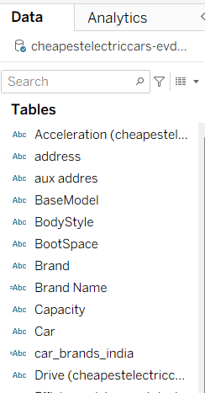
2. | Data Preprocessing | Data preprocessing was performed by handling missing values, removing duplicate records, correcting data types, and creating calculated fields. Units were standardized and unnecessary columns were removed before visualization.  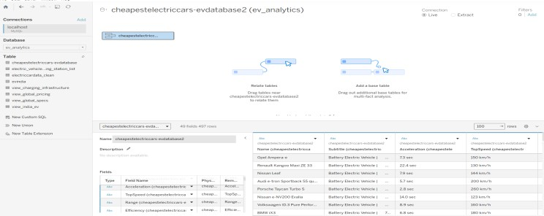

3. | Utilization of Filters | Filters such as Style, Vehicle Type, Charging Type, and Range were applied to enable dynamic interaction in the dashboard.  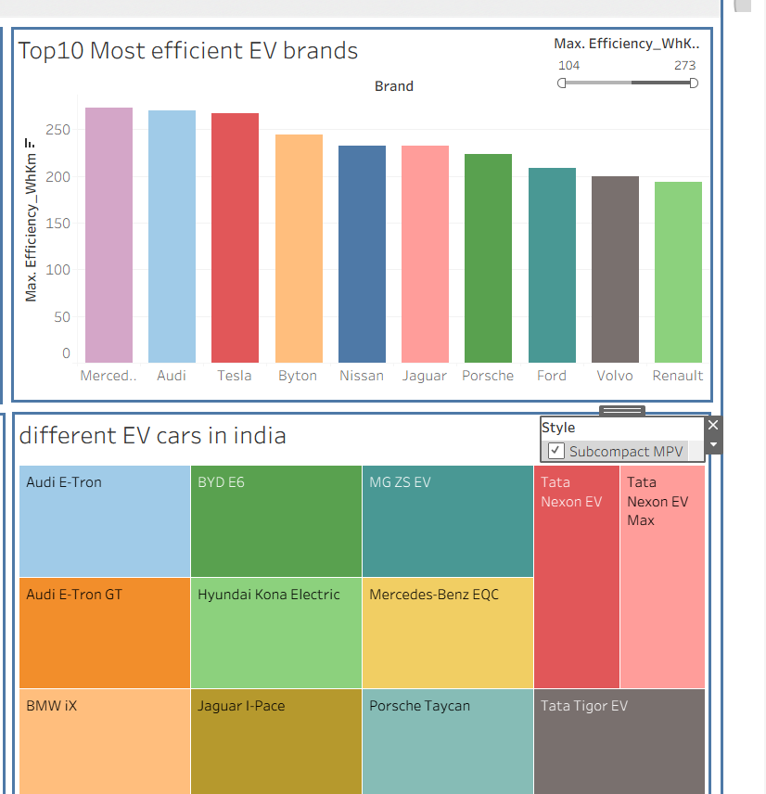
4. | Calculation fields Used | AVG([Range]) COUNT([Vehicle Type])
5. | Dashboard design | No of Visualizations / Graphs – 5  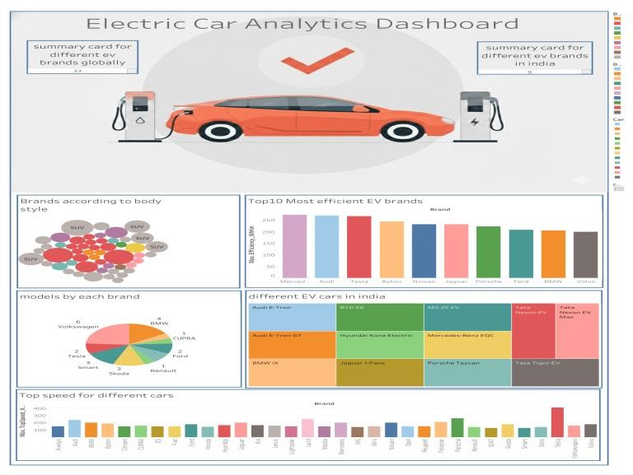

6 | Story Design | No of Visualizations / Graphs – 4  